LYTERATI TRAINING GUIDE FOR ACADEMIC ADMINISTRATORS
(DEPARTMENT HEADS AND DEANS)

NOTE: This document is for use by GW Faculty and Academic Administrators only.

Information in this document is proprietary and confidential.

Distribution of this document is prohibited.

Lyterati Links
Go to this link to access Lyterati:
https://gwu.lyteraticloud.com/login

2. Log into Lyterati

Enter your NetID (the part to the left of the @ in your email address) and email password to log into Lyterati. One of the following reasons may prevent you from logging in:

- Lyterati could not authenticate you. Your NetID or password is incorrect.
- You do not have a role in Lyterati. Contact your College Lyterati point of contact.
- You do not have demographic information in Lyterati. Contact your College point of contact.

Understand the Home Page (also called the Landing Page)

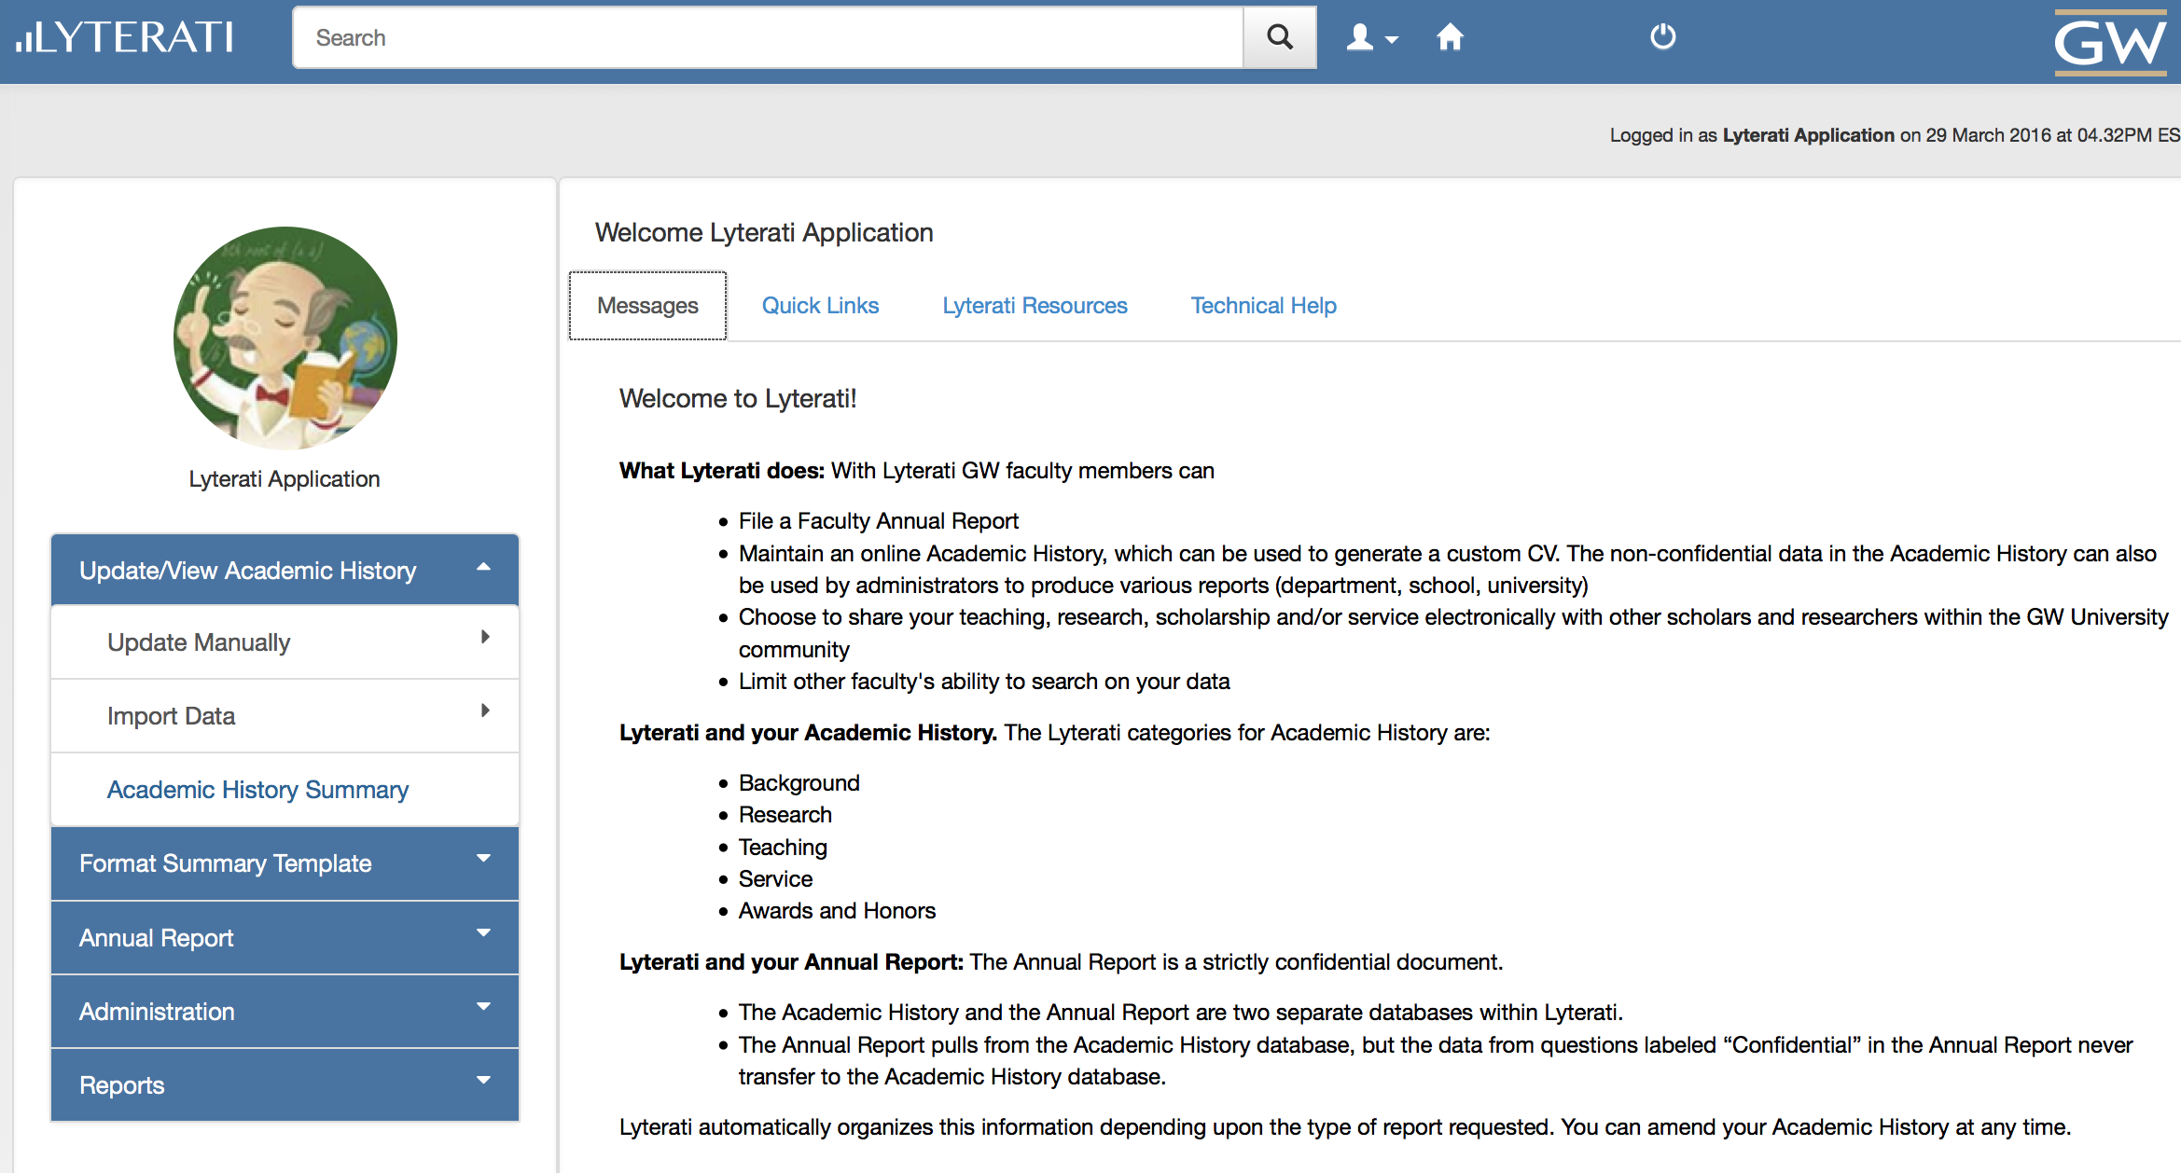
Click on Academic History to access your research, teaching, and service contributions

Click on Annual Report to view historical reports and to create new reports

Lyterati User Guides are here
Upload your photo by clicking on this image

4. Supervisory Comments on Faculty Annual Reports

a. Understand Faculty Process

BEFORE YOU START COMMENTING ON YOUR FACULTY’S ANNUAL REPORTS, UNDERSTAND HOW FACULTY HAVE ENTERED THEIR CONTRIBUTIONS:

- Faculty were asked to follow departmental guidelines on which annual review period to associate a contribution with
- If you see errors in the way contributions were recorded, please work with your faculty to rectify the errors

The suggestions below were provided to your faculty depending on departmental policy:

Sample timeline for an article: Submitted in Aug 2011 -> accepted in Mar 2012 -> published in Apr 2013

Option 1: If your department’s policy is to count a contribution when it is “accepted”, follow the steps below:
Event | Action | Contribution Year/Contribution Month | Additional Details
Submitted in Aug 2011 | Add to “Work in Progress” | 2011/August | Enter “Submitted” in Additional Details along with other information you may want to record.
Accepted in Mar 2012 | Move to Work in Progress to “Articles” | 2012/March | Enter “Accepted” in Additional Details
Published in Apr 2013 | Update existing article | Do not change contribution year/mo | Update additional details with publication date (March 2012 in this case) plus vol, no, page information as applicable.

Option 2: If your department’s policy is to count a contribution when it is “published”, follow the steps below:
Event | Action | Contribution Year/Contribution Month | Additional Details
Submitted in Aug 2011 | Add to “Work in Progress” | 2011/August | Enter “Submitted” in Additional Details along with other information you may want to record.
Accepted in Mar 2012 | Update existing “Work in Progress” | Do not change | Enter “Accepted” in Additional Details
Published in Apr 2013 | Move Work in Progress to Articles | 2013/April | Enter publication date (March 2012 in this case) plus vol, no, page information as applicable.

b. Find your Faculty Member’s Annual Report

Click on Reports on the Left Navigation Menu and then Reports.

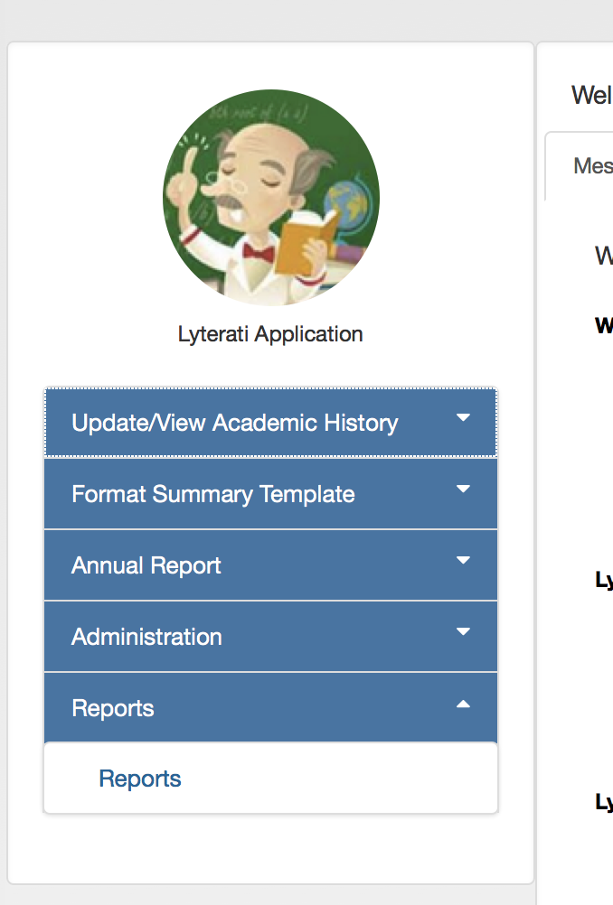
Click on Administrative Reports and then on Annual Review Status Report from the list of reports.

- Select your College and Department
- Select Annual Review Period 2015-2016
- Click on the status you wish to review (see table below)
- Click “Apply”. This report shows only the faculty under your supervision

Who you are | What you want to do | Status Selection
Department Head | See reports that have been submitted by faculty | Select Faculty Review Completed
 | See all reports for faculty in your department | Do not select status
Deans | See only reports where department head has submitted their comments | Select Department Head Review Completed
 | See all reports for faculty in your college | Do not select status

*Note: SMHS has an extra level of supervision known as the Division Chief. Division Chiefs can see reports that have been submitted by faculty by selecting the status “Faculty Review Completed.” Department Heads in SMHS can select “Division Head Review Completed” to see reports ready for their review.

Lyterati will now show you a list of faculty matching your college, department, year, and status selections.
- Click on the faculty member’s name to go to their report
- This will take you to the faculty’s annual review page.
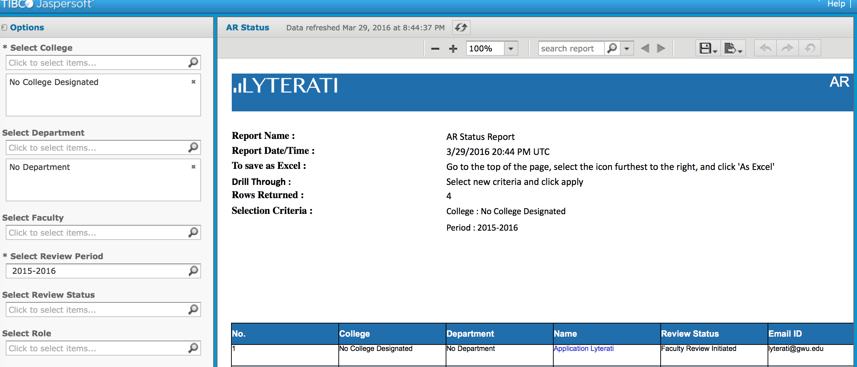
- Click on Edit. Lyterati will show you the annual report page for the faculty and allow you to comment on the report as shown below.

Department Head’s Comment Page
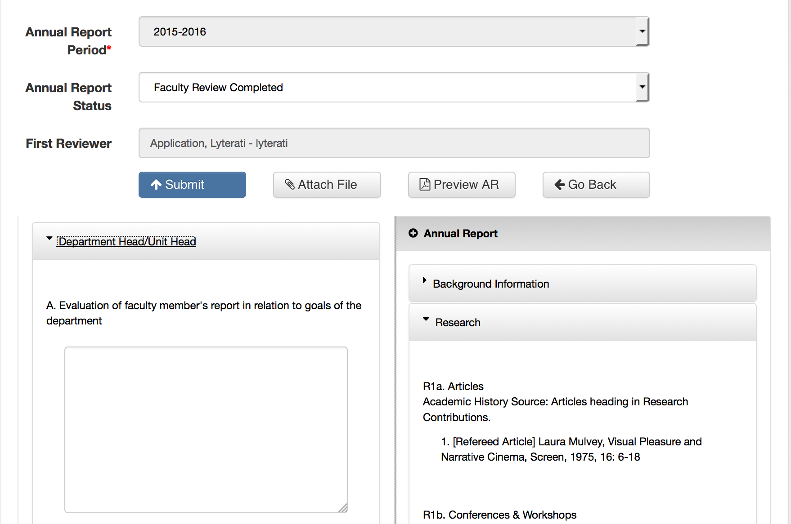

Faculty responses
Size the right and left splits by dragging the arrow left or right.
Dept. head questions

The left split and right splits can be sized by dragging the double bars in the middle horizontally. If your browser does not show you vertical scroll bars in the left and right split, hold the mouse over where the scroll should be and it will appear. Alternately, click into the left or right split and scroll down using the up and down keys.
Dean’s Comment Page
Click to view either the faculty’s annual report or the department head’s report

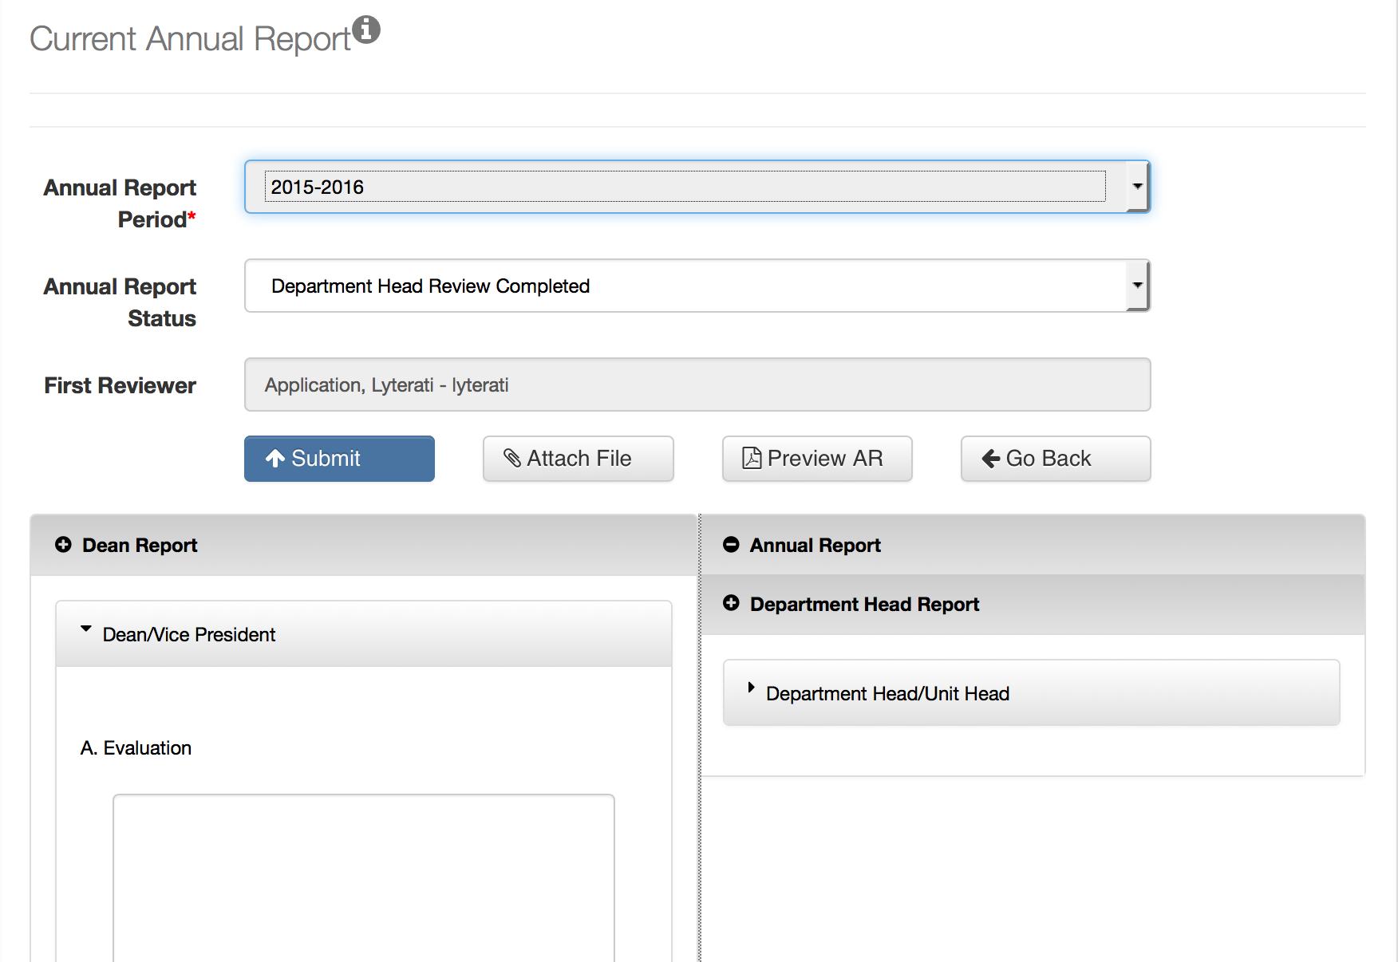

Here is how the content is laid out:

- Dean gets his/her questions in the left pane.
- In the right pane, you will see the faculty’s responses under Annual Review and the Department Head’s questions and responses under Department Head Report

In one page, you are able to see all the questions and responses. You can also click on “Preview AR” to see a printable document with all the questions and responses.

c. Answer supervisor questions

On the left side of the split screen you will see the questions that you need to answer. Answer your questions. The application will save when you click out of an answer box.

You can save and exit at any time. To continue editing, click on Administration | ManageM y Unit’s AR and then edit the annual review that is already in progress.

d. Review your answers

Click on “Preview AR” to view your answers in PDF format. You can also save a copy of the PDF for your records.

e. Review Documents Submitted with Annual Reviews

Your faculty may have submitted CVs and teaching evaluation documents with their annual review. Click on “Attach File” to view these documents.

f. Submit your Comments

Note: If you are a designee you will not be able to submit. Only the person on whose behalf you are acting will be able to submit the review. Others follow the steps below. Designees should exit after they have added their comments.

When you are satisfied with your responses, click on Submit on the top of the page to send the annual review electronically to your supervisor.

The review status will change to “Department Head Review Completed” or “Dean Review Completed” depending on your responsibility*.

*SMHS has a level of review before Department Head called “Division Chief.”

Notes:
- When you submit, you will be asked to verify that you are authorized to submit this annual report. This acknowledgement serves as an electronic signature.
- In case you or a faculty member who reports to you prematurely submits an annual report to your supervisor, your supervisor can “release” the annual review by changing the annual review status to an earlier status.

g. “Release” an Annual Report

If you are a department head/dean or the designee of a department head/dean, your faculty may ask you to “release” an annual report because they submitted their report prematurely.

In either case, here are the steps to release a report.

- Find the annual report that needs to be released by following the steps in “b” above.
- Click on the pencil to edit the annual report.
- Click on the Annual Report Status drop down and set the status to an earlier status:
- If you are a department head releasing a report to a faculty member, set the status to “Faculty Review Initiated”
- If you are a Dean releasing a report to a department head, set the status to “Faculty Review Completed”
- Click on Submit and follow the instructions.

Note:

If you are a CLAD, you can go to Administration|Release AR and search for the faculty in your college whose AR you’d like to release.

h. Meet with Faculty (Department Head)

If you are a department head and the dean’s review is complete, meet with the faculty to review the supervisor comments. Then ask the faculty to do the Faculty Acceptance step.

If you are a department head, you can share your comments with the faculty member using the Preview AR feature. Email the PDF document to your faculty member.

