LYTERATI ANNUAL REPORT GUIDE FOR FACULTY MEMBERS

NOTE: This document is for use by GW Faculty and Academic Administrators only.

Information in this document is proprietary and confidential.
Distribution of this document is prohibited.

Table of Contents
1. Lyterati Links 3
2. Log into Lyterati 3
3. Create a New Annual Report 3
4. Answer Annual Report Questions 5
4a. Select from Academic History 6
4b. Add a New Contribution 7
4c. Add a Document to your Contribution (Optional) 9
4d. Answer Conflict of Interest Questions 10
4e. Attach Documents to your Annual Report (Optional) 10
5. Review your Answers 11
6. Submit your Annual Report 11
7. View Prior Annual Reports 13

Lyterati Links
Go to one of these links to access Lyterati:
http://www.gwu.edu/faculty-staff
http://provost.gwu.edu/forms
http://www.gwu.edu/az-index

2. Log into Lyterati

Enter your NetID (the part to the left of the @ in your email address) and email password to log into Lyterati. One of the following reasons may prevent you from logging in:

- Lyterati could not authenticate you. Your NetID or password is incorrect.
- You do not have a role in Lyterati. Contact your College Lyterati point of contact.
- You do not have demographic information in Lyterati. Contact your College point of contact.

3. Create a New Annual Report

Click on the Annual Report menu in the left navigation bar and then click on Current Annual Report.

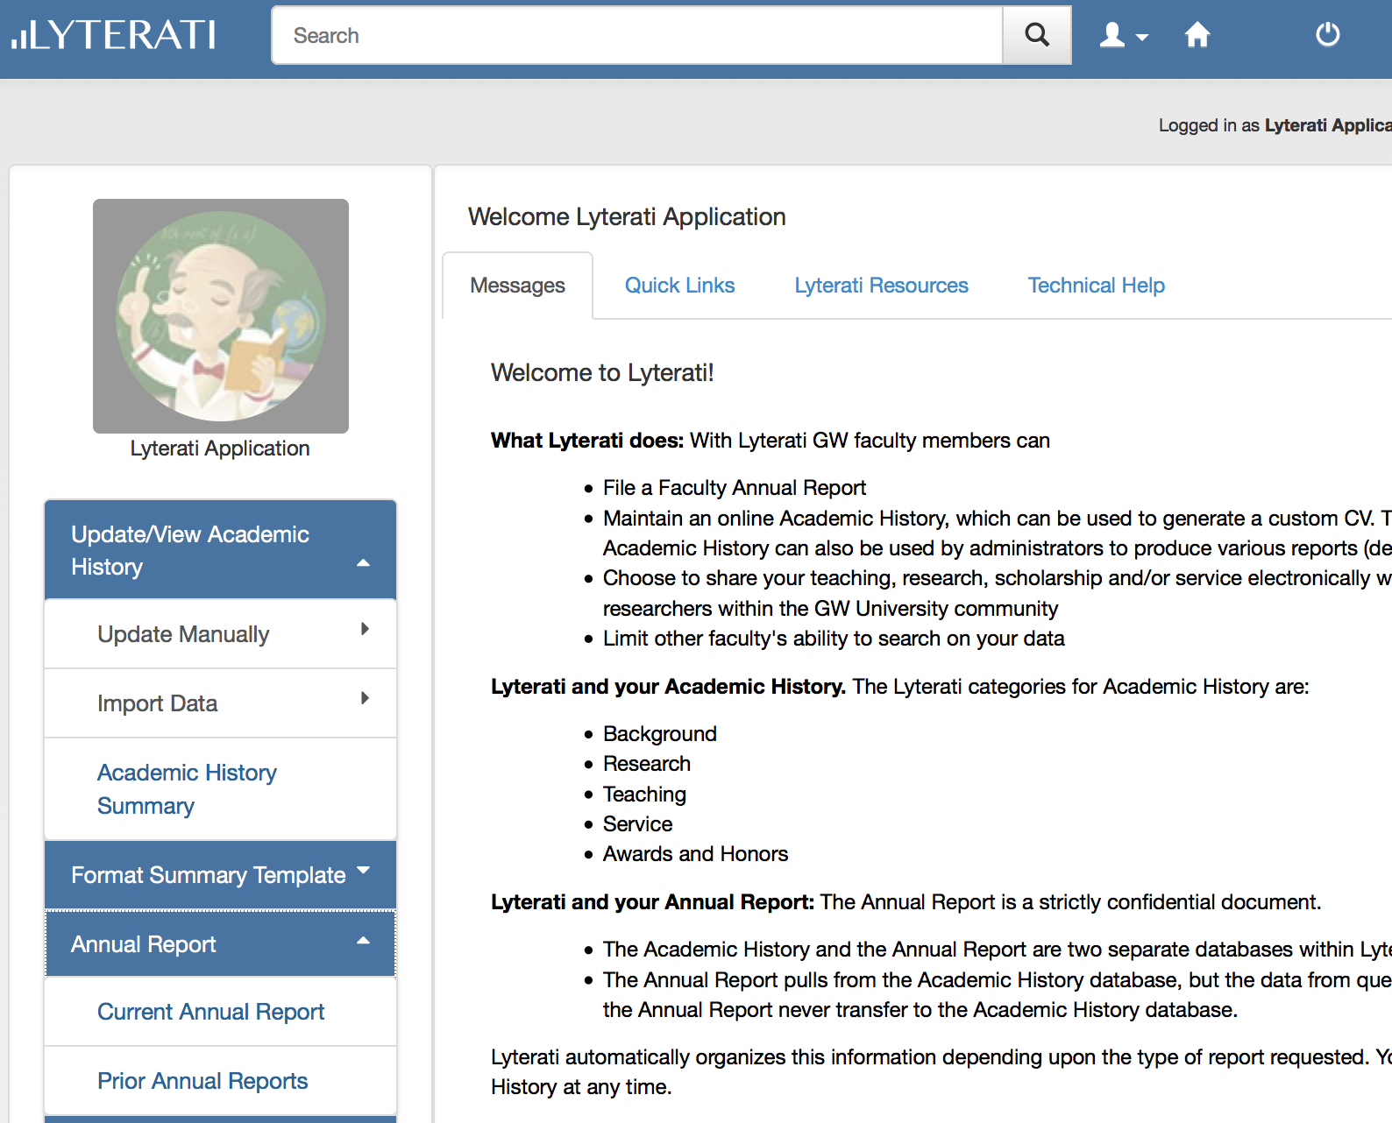

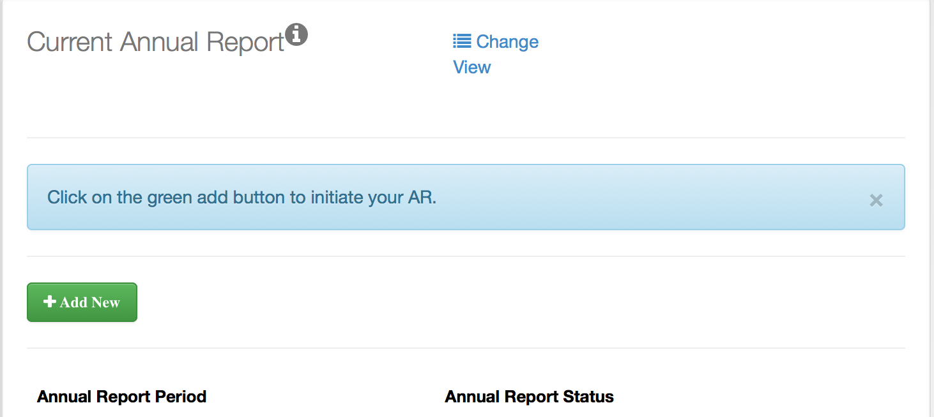
Click on the green Add button to initiate the creation of the 2014-15 Annual Report. You can only create one report for a particular year.

On the page below, click Create. You will be able to see the name of your first reviewer.

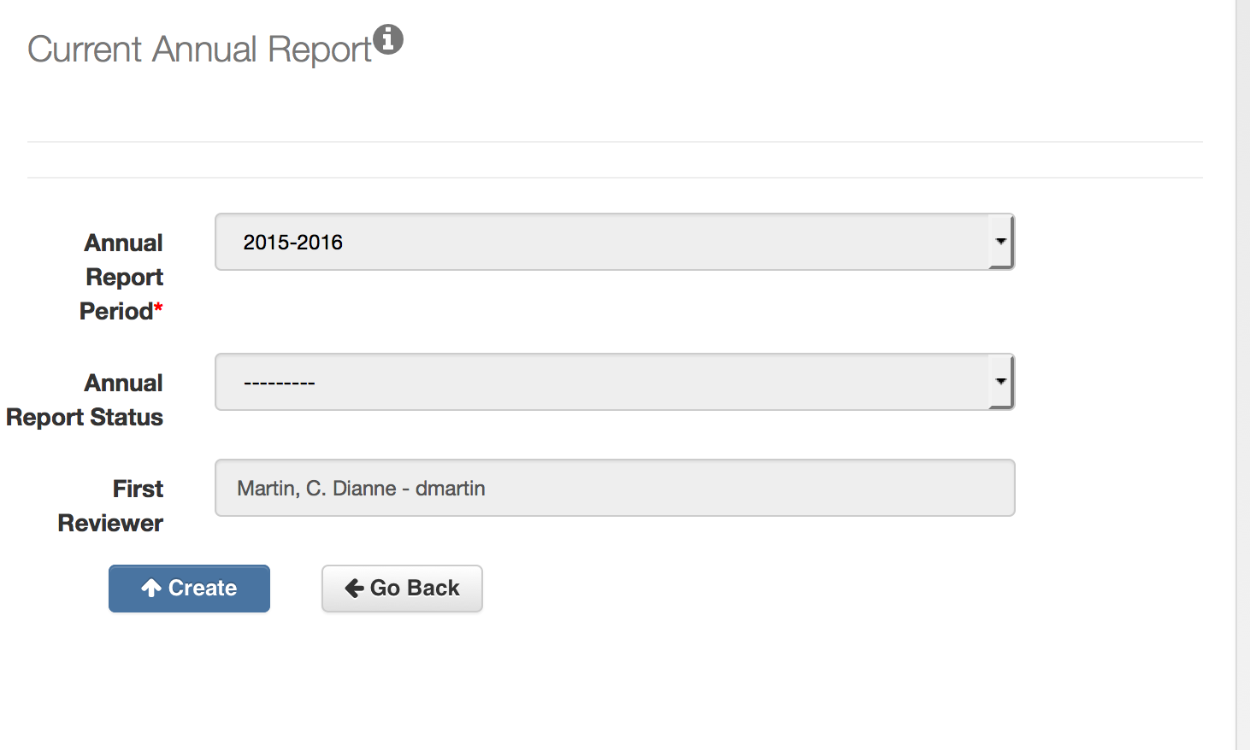

Lyterati will show you the following page once your Annual Report is created.
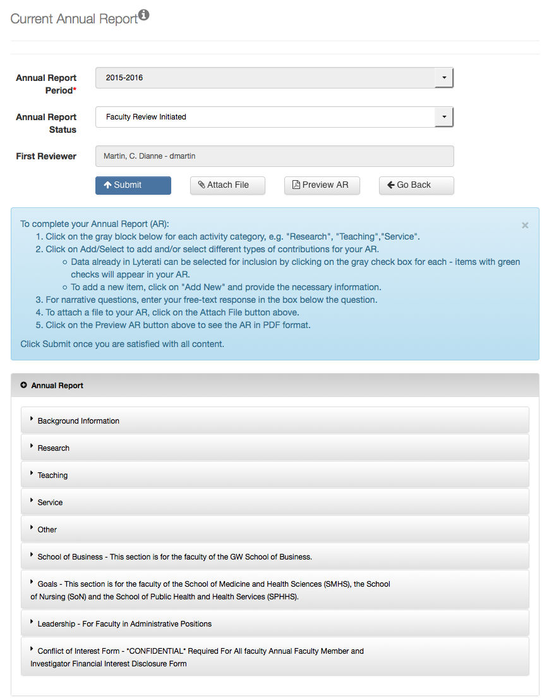
The GW Annual Report has nine blocks:

- Background Information
- Research
- Teaching
- Service
- Other
- School of Business
- Goals
- Leadership
- Conflict of Interest

Each block contains questions that are specific to your contribution for that area.

4. Answer Annual Report Questions

Start with Background Information (question B1) and scroll down, reviewing and answering each question. Your responses will save automatically. You can save and exit at any time. To continue editing, click on Annual Report and then edit the annual report that is already in progress.

Click on the arrow to the right of Background Information to see all the questions in the block:

Once the questions are open, proceed with answering them by clicking on the Add/Select link to the right of the question.

4a. Select from Academic History

When you click on Add/Select, the current records will show in Lyterati. Check the ones you want to insert into your report by clicking on the box underneath “Include in AR” next to the record. You can edit the record from here as well by clicking on the pencil icon. To remove selections, unclick the box.

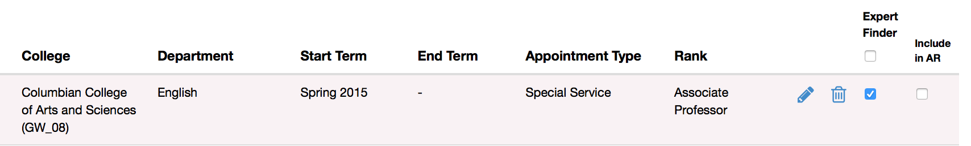

Make sure that you see the green checkmark as shown below. This indicates that the article will show on your annual report.

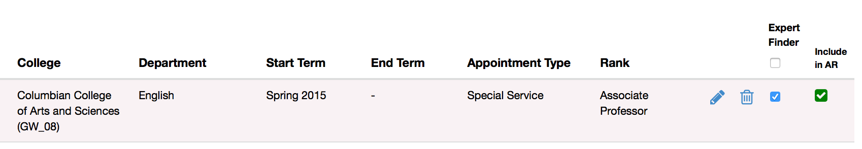

Close the window by clicking on the “x” on the top right corner.

4b. Add a New Contribution

To add a new contribution, click on the green Add New button.

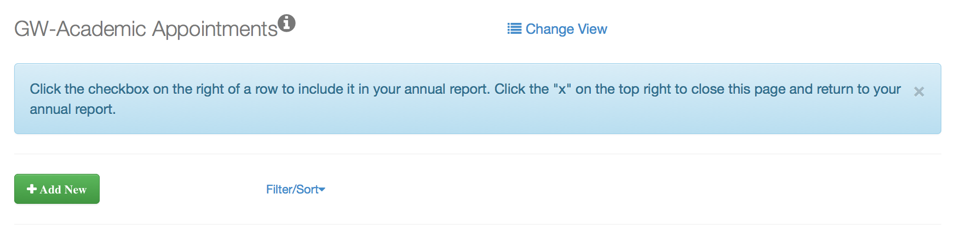

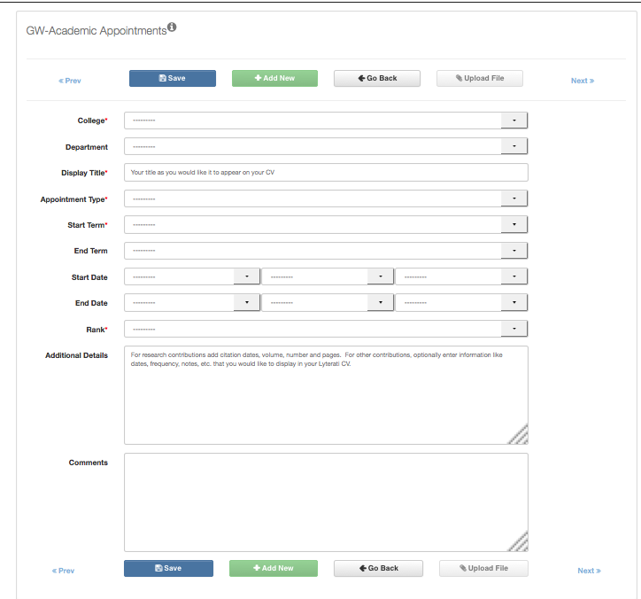
This will take you to a blank contribution page. Here you can add the citation details as shown below.

The required fields are marked with an asterisk.

Note: An easy way to add the citation is to copy or enter your citation into the Additional Details box and drag the relevant portion of the citation into the appropriate fields (e.g., Display Title) and then setting Contribution Type and Contribution Year and Month.

Scroll down to see the URL, Comments, and Tags fields. You can add a URL or a DOI in the URL box. You can also enter comments for your supervisor to see. For research, teaching, and service contributions, select one or more tags that relate this contribution to the pillars in the GW Strategic Plan if relevant.

Follow your department/college norms regarding the annual report period in which a contribution should be counted. Examples are shown below.

Sample timeline for an article: Submitted in Aug 2011 -> accepted in Mar 2012 -> published in Apr 2013

Option 1: If your department’s policy is to count a contribution when it is “accepted”, follow the steps below:
Event | Action | Contribution Year/Contribution Month | Additional Details
Submitted in Aug 2011 | Add to “Work in Progress” | 2011/August | Enter “Submitted” in Additional Details along with other information you may want to record.
Accepted in Mar 2012 | Move to Work in Progress to “Articles” | 2012/March | Enter “Accepted” in Additional Details
Published in Apr 2013 | Update existing article | Do not change contribution year/mo | Update additional details with publication date (March 2012 in this case) plus vol, no, page information as applicable.

Option 2: If your department’s policy is to count a contribution when it is “published”, follow the steps below:
Event | Action | Contribution Year/Contribution Month | Additional Details
Submitted in Aug 2011 | Add to “Work in Progress” | 2011/August | Enter “Submitted” in Additional Details along with other information you may want to record.
Accepted in Mar 2012 | Update existing “Work in Progress” | Do not change | Enter “Accepted” in Additional Details
Published in Apr 2013 | Move Work in Progress to Articles | 2013/April | Enter publication date (March 2012 in this case) plus vol, no, page information as applicable.

4c. Add a Document to your Contribution (Optional)

You can add a document to your contribution AFTER you have saved the contribution. To attach a document, click on the Upload File button.

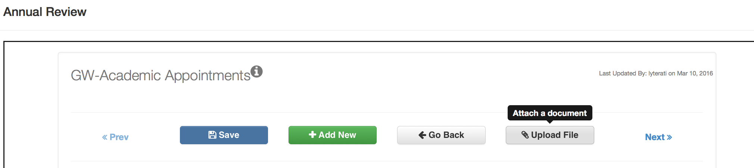

This will take you to the Attach Documents page. Browse your computer for the document you wish to upload and then click Upload. After the upload is completed, you will see your document on the bottom of the page.

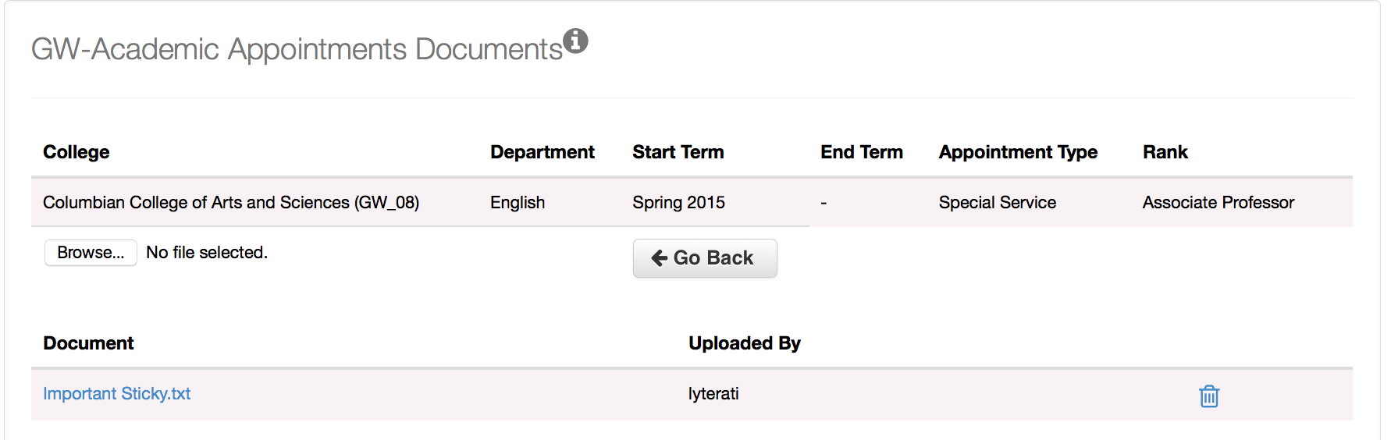

4d. Answer Conflict of Interest Questions

There are only two conflict of interest questions. The first question is mandatory. If you answer this question with a “Yes,” then the following question is also mandatory. You will not be able to submit the annual report without answering the mandatory questions.

4e. Attach Documents to your Annual Report (Optional)

On the header of the Annual Report, click on Attach File to upload a document to your annual report. Follow your department or college’s instructions on attaching documents such as your CV or Teaching Evaluation documents.

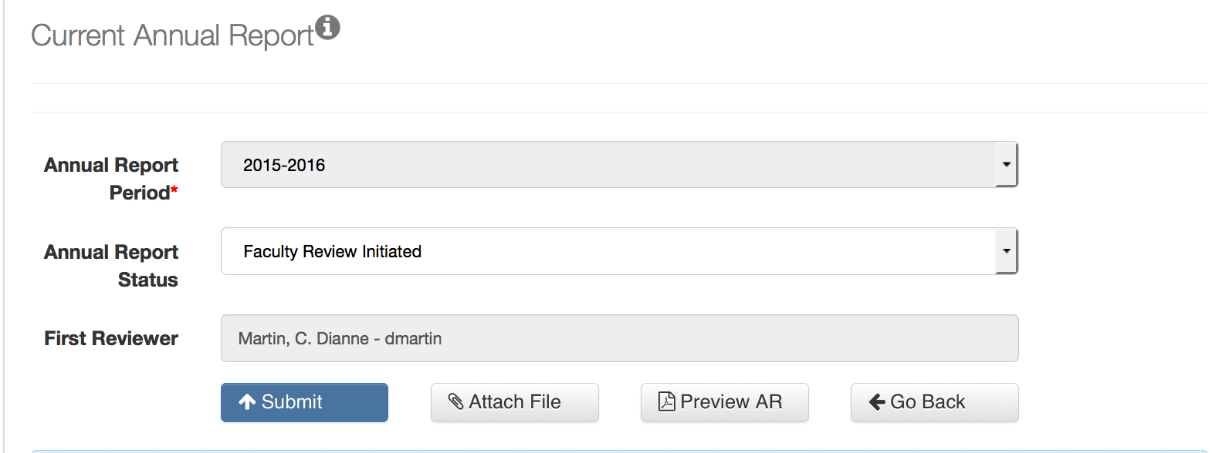

On the Upload Documents page, browse for the file you want to upload by clicking on “Choose File” and then click Upload. You can upload more than one document.

5. Review your Answers

Click on Preview AR to view all your answers in a PDF document. Retain a copy for your records.

6. Submit your Annual Report

When you are satisfied with your responses, click on Submit on the top of the page to send the annual review electronically to your supervisor.

After you submit the annual report, the status of your report will change to “Faculty Review Completed”.

When you submit, you will be asked to verify that you are authorized to submit this annual report. This acknowledgement serves as an electronic signature.

Notes:
- Once you submit, you will be able to recall your annual report if your supervisor has not yet commented on it. To do this, click on the Recall button that appears after you submit to regain the ability to edit your annual report.

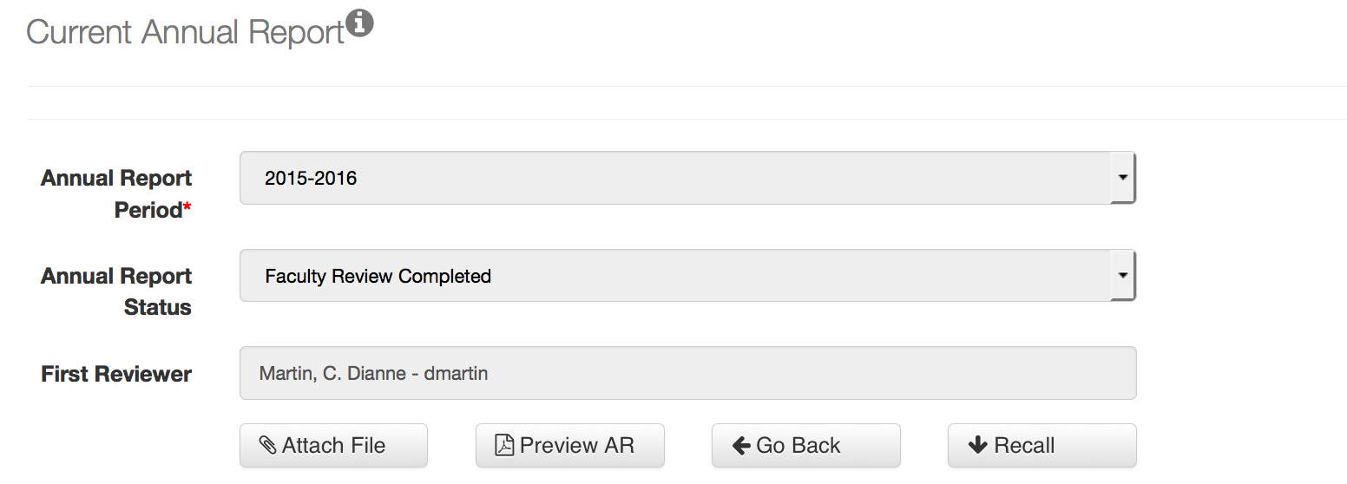

If you cannot see this button, it means that your supervisor has begun commenting on your annual report. In this case, your supervisor can “release” the annual report by changing the annual report status to an earlier status.

7. View Prior Annual Reports

Click on the Annual Report menu in the left navigation bar and then click on Prior Annual Reports.

Here you can view any previous annual reports you have completed in Lyterati. Click on the document icon to download your annual report as a PDF.

